Video no - 22 ------------- **slice range syntax**

let talk more about slices:-

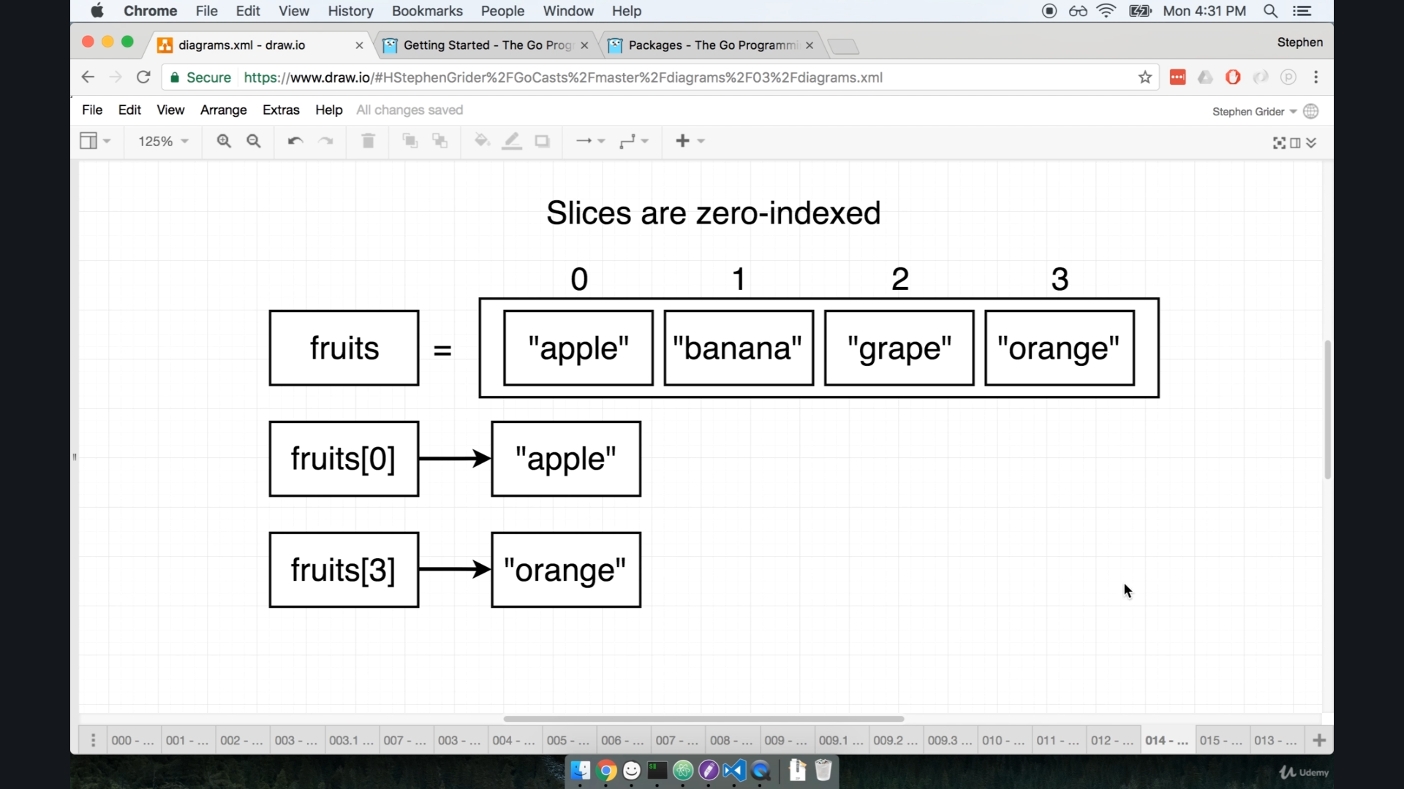

fruit[0:2] ==> apple , banana ---> just like we did in python.

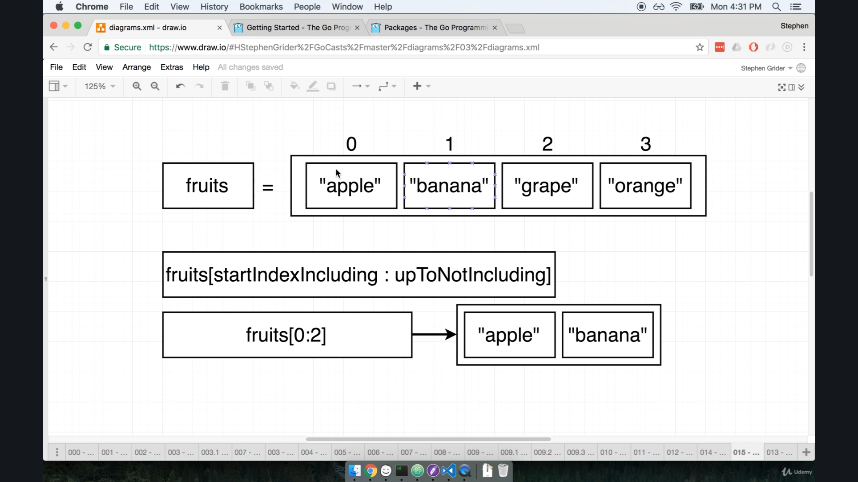

so this syntax actually applied a range over slice.

==> fruits[consider: consider-1]

also we can leave blank in either side of colon.

fruit[:2] as we do in python.

same we can do with our card peoject :-

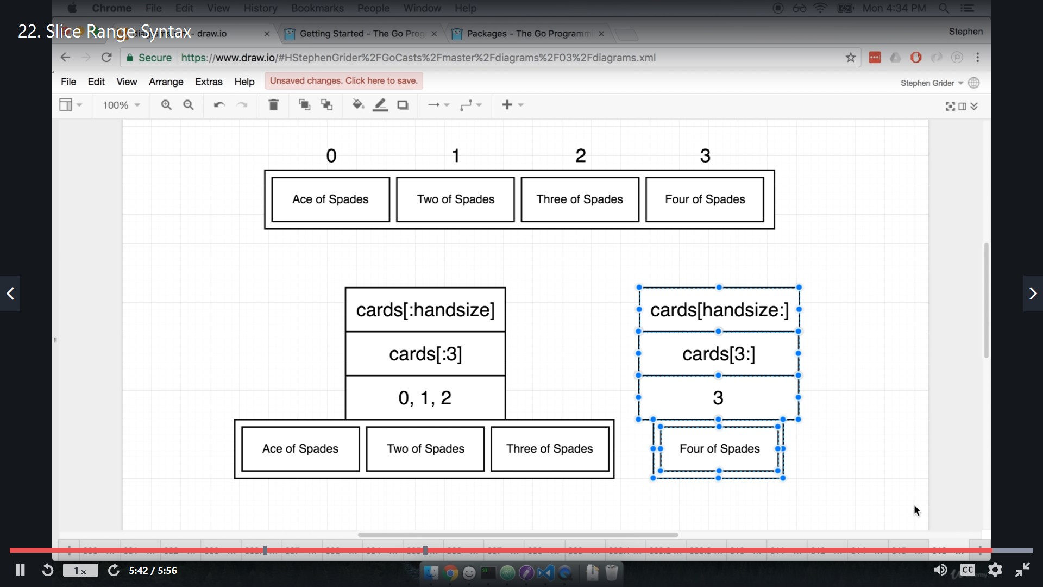

video no - 23 ==> **return multiple values**.

deck.go

func deal(d deck, num int) (deck, deck) {

    return d[:num], d[num:]

}

we can see that if we have two return type we kept that in braces.

main.go

func main() {

    cards := newDeck()

    cards.print()

    deckUptoNum, deckAfterNum := deal(cards, 2)

    fmt.Println(deckUptoNum)

    fmt.Println(deckAfterNum)

}

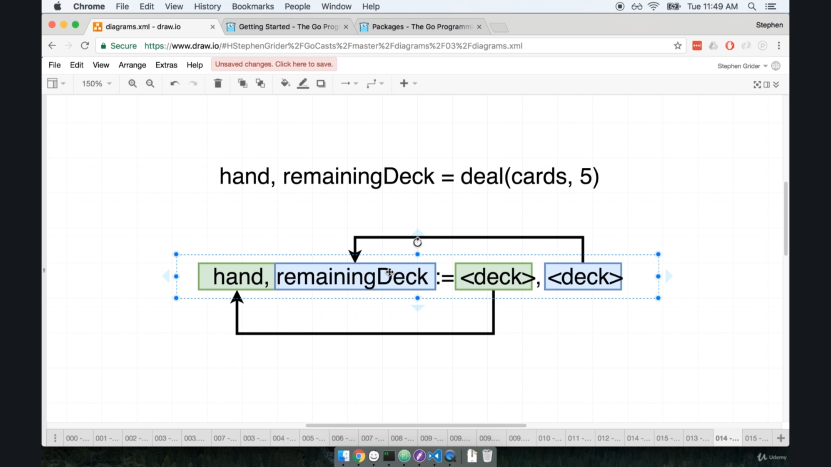

Video no -- 24, name ==> **byte slice**

here we talk about saving something to hard drive

and later reading that file

Below is image from go lang documentation

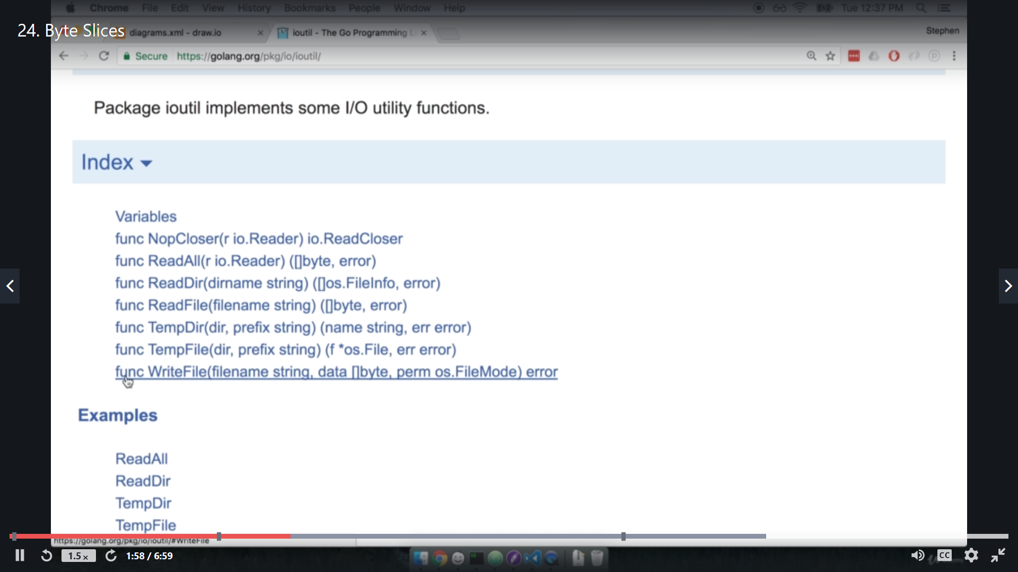

Here we are going to use one in-build package called **ioutil,** this will be responsible for all io operation with hard-drive.

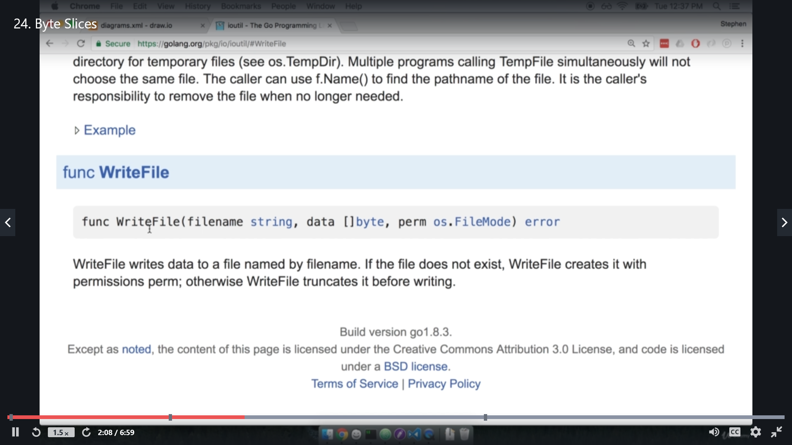

this is **WriteFile** function mainly use to edit a new or existing file in filesystem.

here []byte is actually a slice of byte or simple a **byte slice.**

perm os.Filemode is R/W permission to edit a file or not.

what is byteslice ?

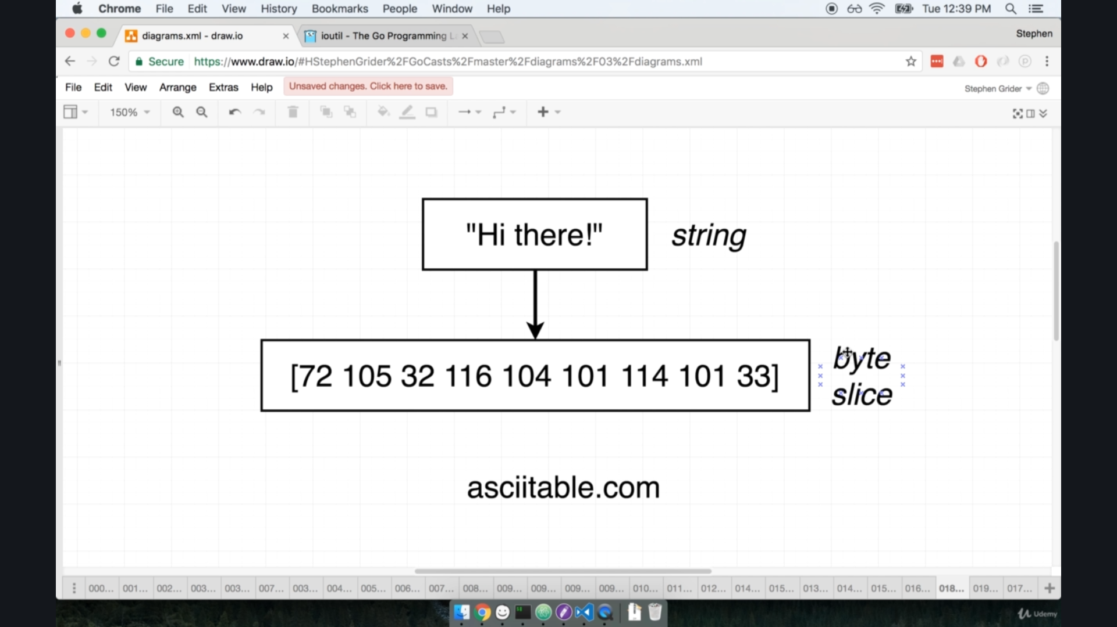

byte slice is ascii code binary for string.

we need to convert a deck type into byte-slice.

because human are friendly with string but not with ASCII codes.

Video no = 25 name = **Deck to string**

**Type conversion in golang**

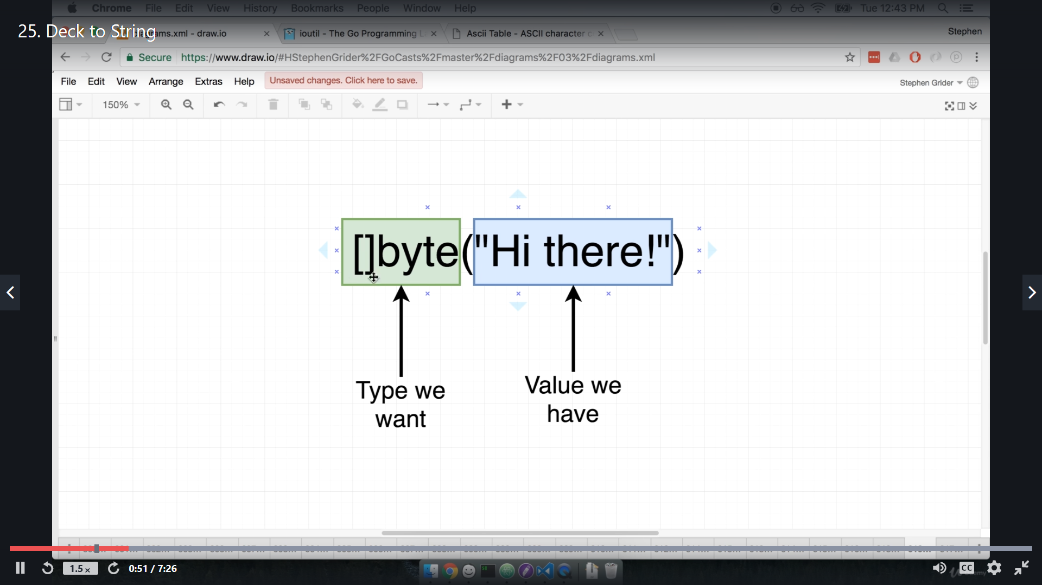

we can do type conversion with the **type** that we want and I value to be converted.

lets try that

fmt.Println([]byte("Hi there"))

}

o/p => [72 105 32 116 104 101 114 101]

this is byteslice for the string.

but the question is that how can we convert a **deck type into byteslice ?**

so here is flow that we are essentially go through:-

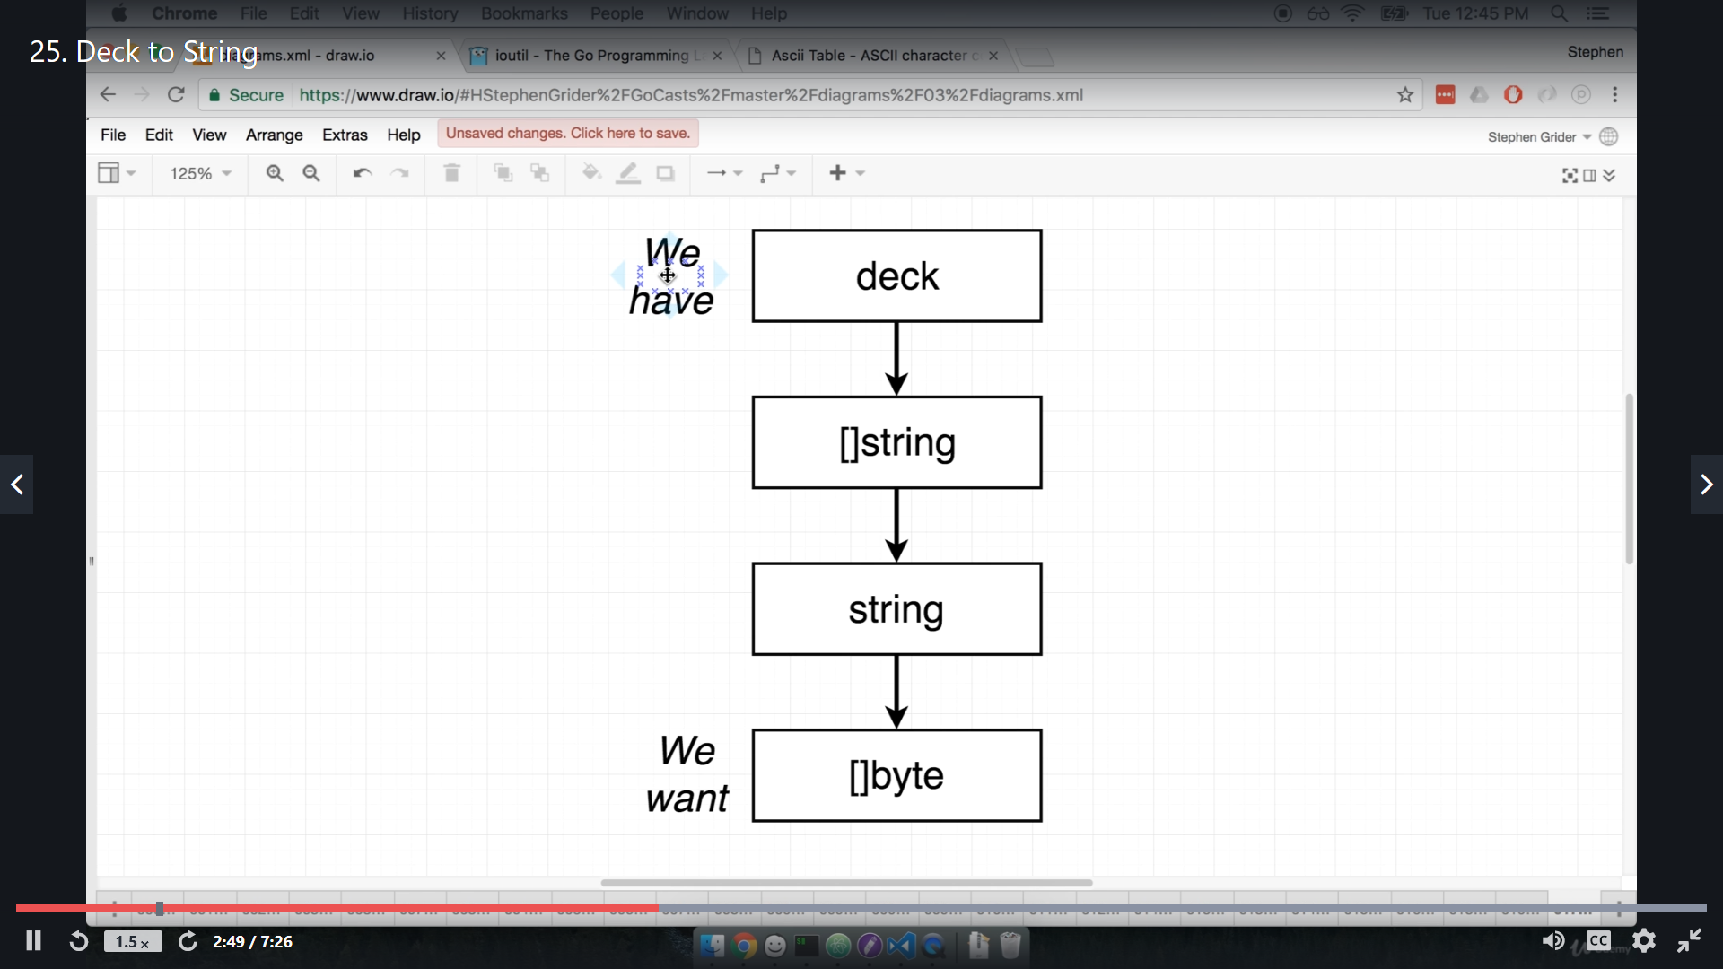

1. we will convert a deck type into string slice.
2. then string slice to merge down to single string.
3. then this string will be converted to byte slice.

now to convert **string slice into a single string** we are going to use another package called "**strings**".

so this package "strings" have some basic common function which is used to dealing with strings.

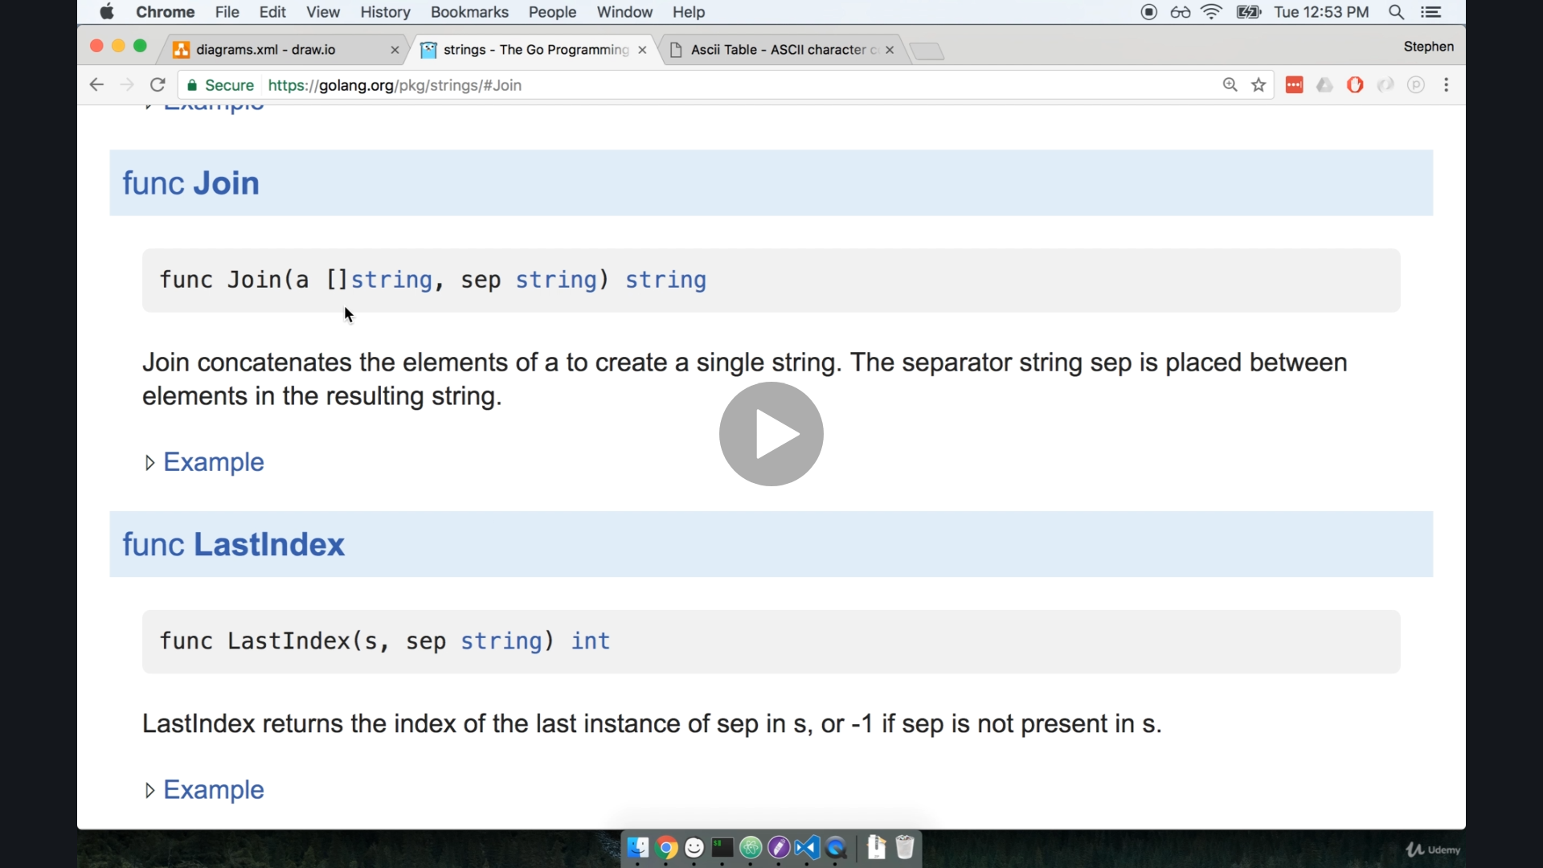

Here in documentation, in package **strings**  , we have a function **join .**

so we need to pass a string slice and separator and this will return a single string.

Also to import new package we do not write import keyword again, instead of this we will write package **within same import statement** using "**()**" , and every new package will be listed by in **only new line**.

like this

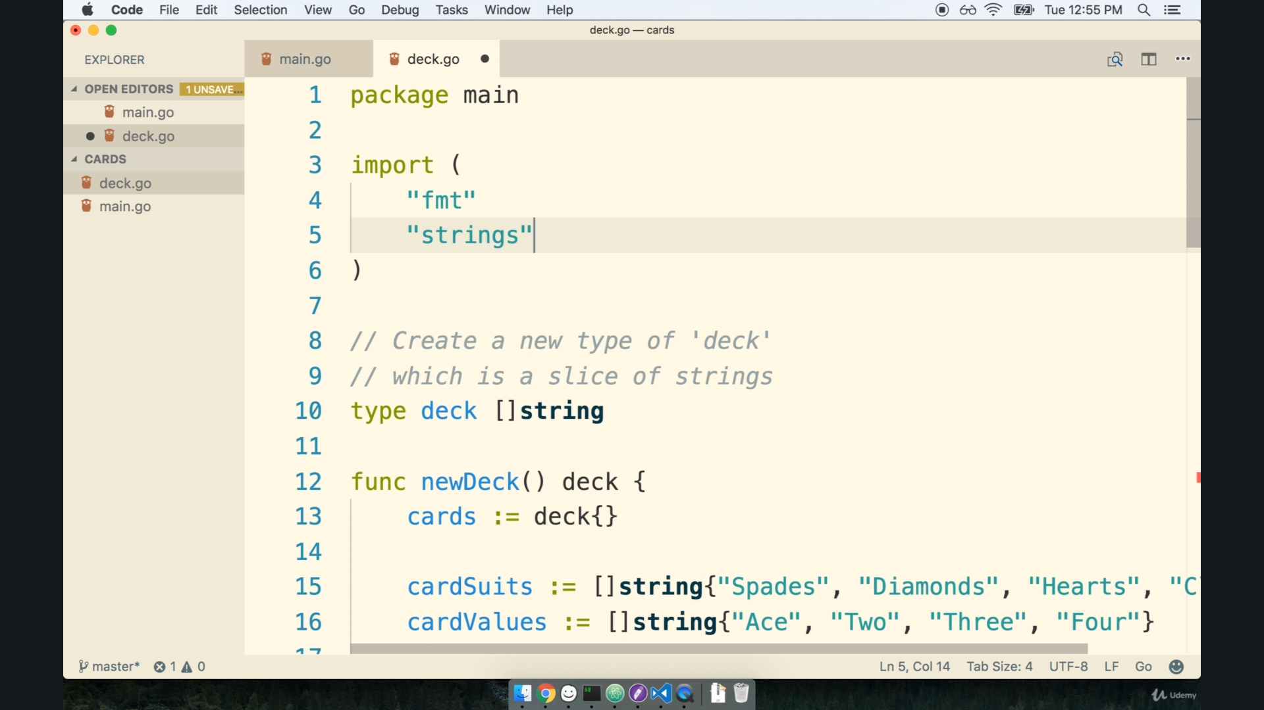

package main

import "strings"

func (d deck) toString() string {

    deckStringSlice := []string(d)

    singleString := strings.Join(deckStringSlice, ",")

    return singleString

}

**main.go**

func main() {

    cards := newDeck()

    fmt.Println(cards.toString())

}

> go run .\main.go .\toString.go .\deck.go

spade of ace,spade of two,spade of three,spade of four,heart of ace,heart of two,heart of three,heart of four,diamond of ace,diamond of two,diamond of three,diamond of four

now we need to convert this all into **byteslice**

**video no - 27, name - save data to harddisk.**

"error" is also some kind of datatype in Golang

WriteFile function have return type as error.

g=> []byte(d.toString()) by this way we can convert string into byteSlice.

premission => 0666 => this mean "0 " octal number and 666 are read and write permission to everyone.

toSaveFile.go

func (d deck) toWriteFile(fileName string) error {

    return ioutil.WriteFile(fileName, []byte(d.toString()), 0666)

}

Note:- ioutil is deprecreted, us   
  
import (

"os"

)

func (d deck) towrite(filename string) error{

return os.WriteFile(filename, []byte(d.toString()), 0666)

}

main.go

func main() {

    cards := newDeck()

    err := cards.toWriteFile("myfile.txt")

    fmt.Println(err)

}

**Video no-28, name - reading File from harddrive**

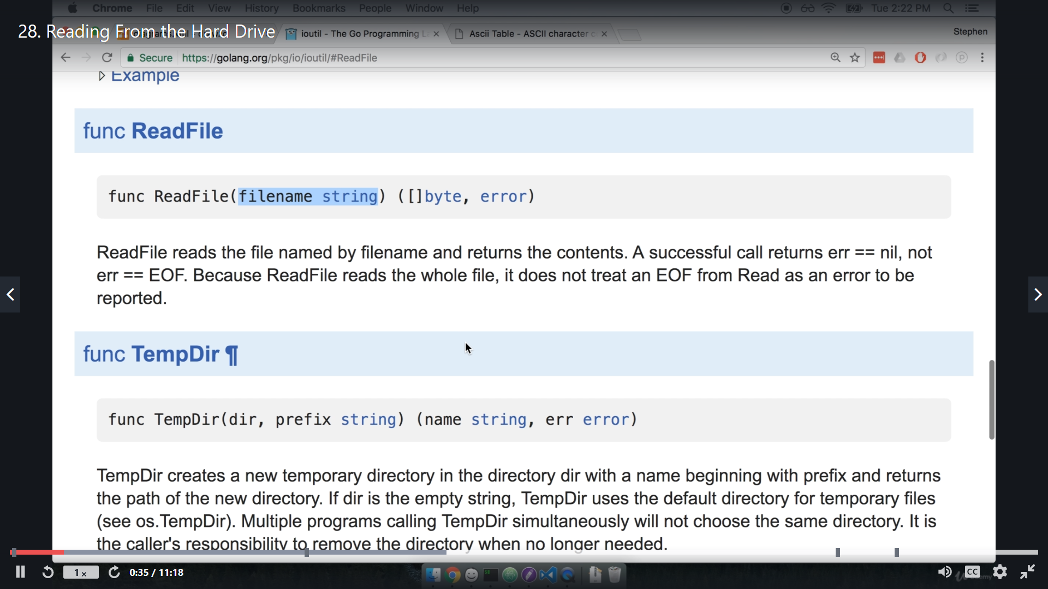

This is ReadFile function and this will return a byteslice ([]byte) we can typecast to string.

this is single string and our card name is separated by comma (,), so we can convert into string-slice.

for that we have a function in package strings as **Split.**

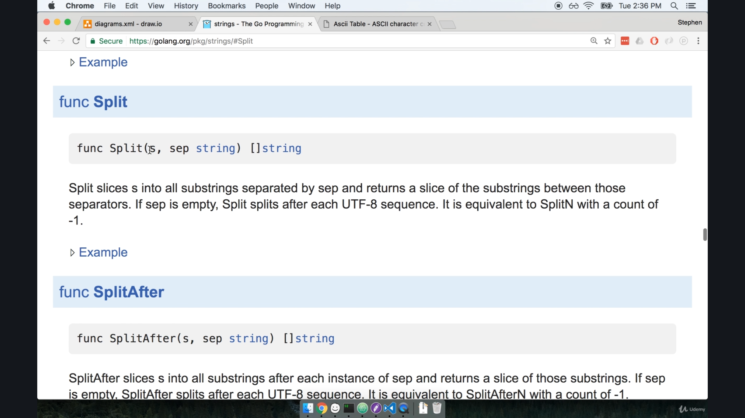

So this Split function takes our string and separator and return string-slice.

readFile.go

import (

    "fmt"

    "io/ioutil"

    "os"

    "strings"

)

func (d deck) toReadFile(filename string) ([]string, error) {

    dataByte, err := ioutil.ReadFile(filename)

    if err != nil {

        fmt.Println("Error: ", err)

        os.Exit(1)

    }

    dataString := string(dataByte)

    dataStringSlice := strings.Split(dataString, ",")

    return dataStringSlice, nil

}

main.go

func main() {

    cards := newDeck()

    dataStringSlice, _ := cards.toReadFile("myfile.txt")

    for i, dataString := range dataStringSlice {

        fmt.Println(i, dataString)

    }

}

now lets talk about this **error** object

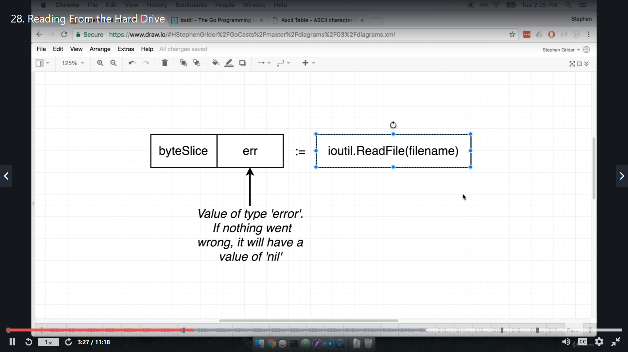

**"err" is value of type "error"**

lets look how to log an error.

we can also **exited** from the program if error occur for existed we have another package **"os"**

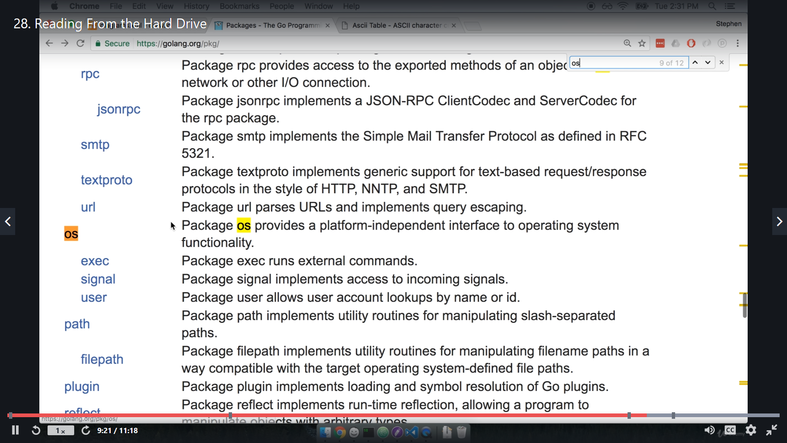

"os" package work same regardless of package.

It have an ====> Exit(statusCode int) function.

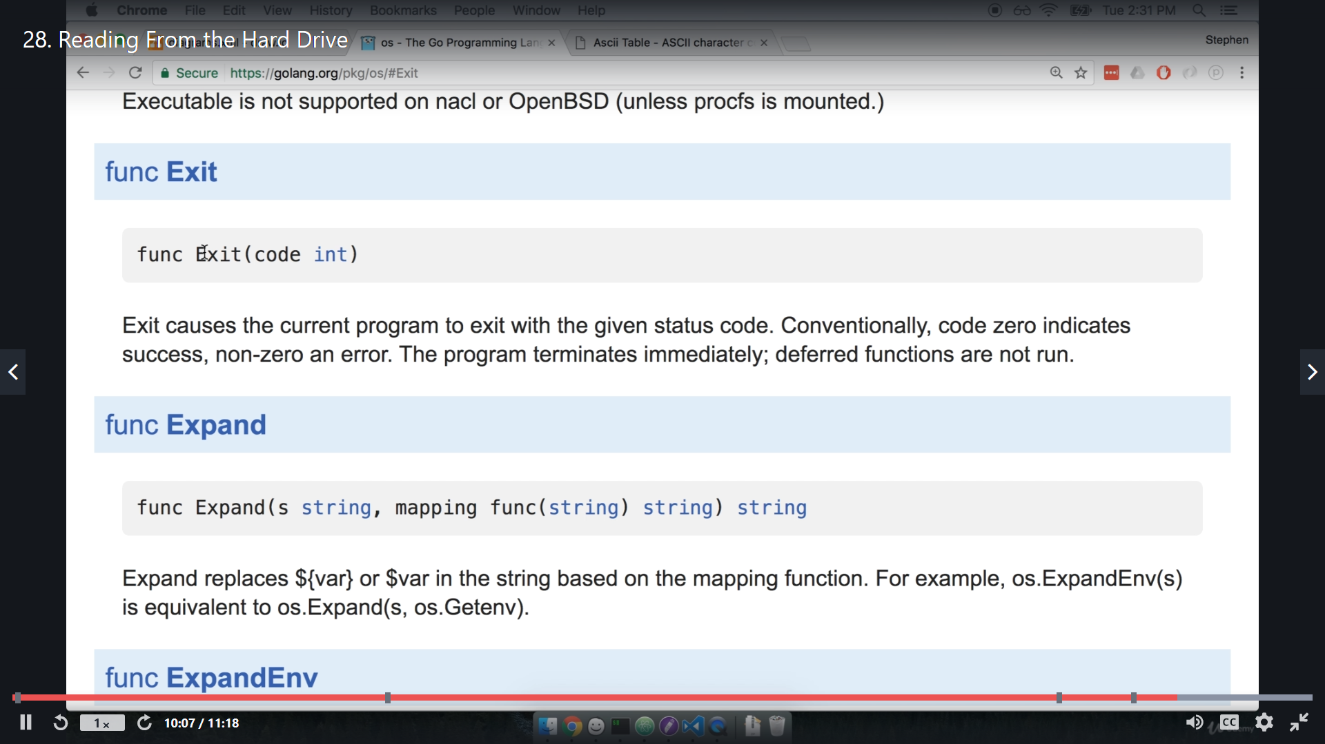

os.Exit(1) => for error exit

**video no-30, name - shuffle a deck**

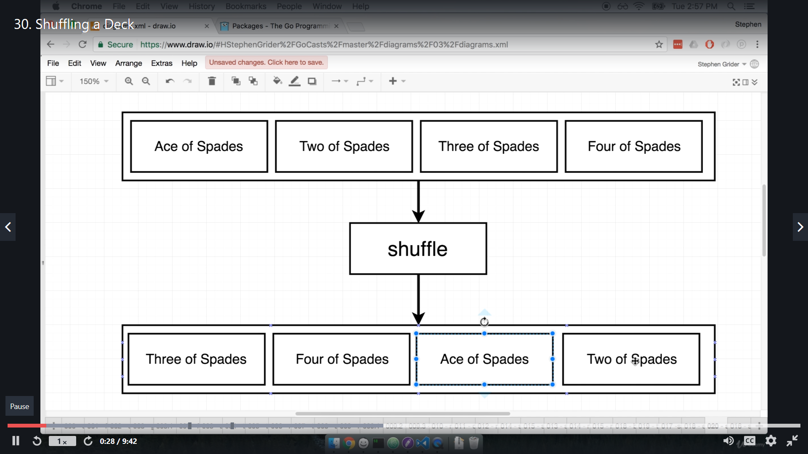

so when we give a string slice to a shuffle function it will return **string slice in random order** .

But built in library does not have any function for shuffle.

so use this logic for that.

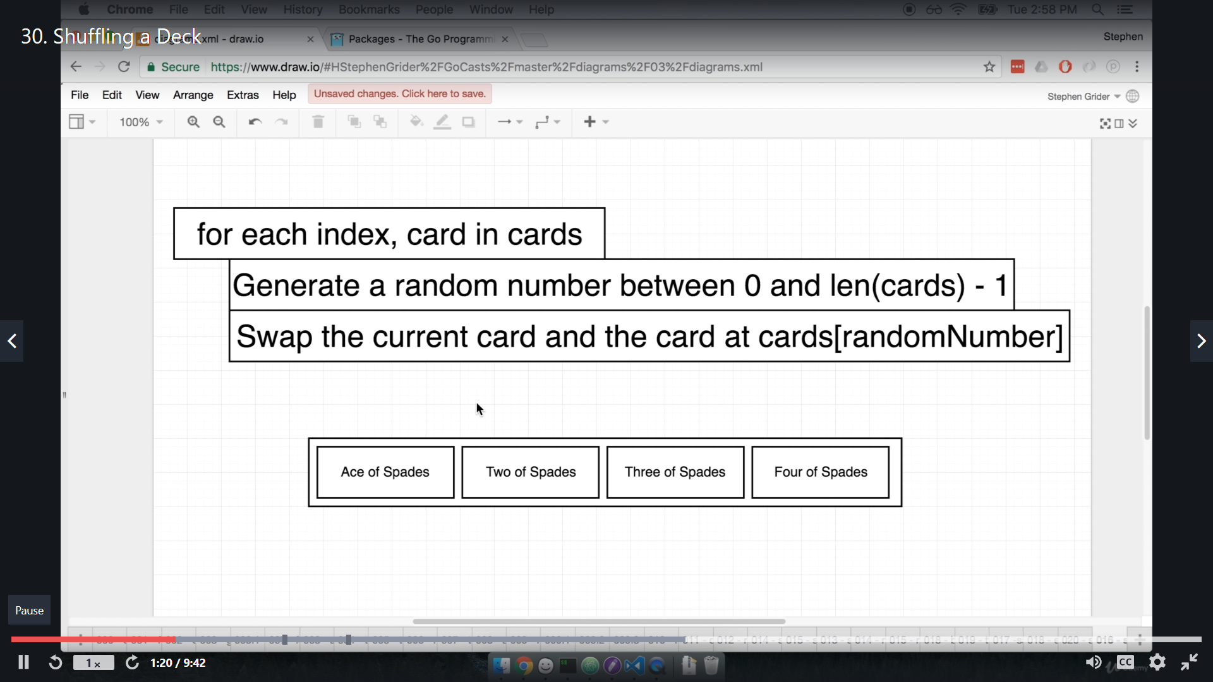

So to generate a random number, there a **package math** and inside this math package there is sub package called **rand** and this rand package contain a **function name Intn**

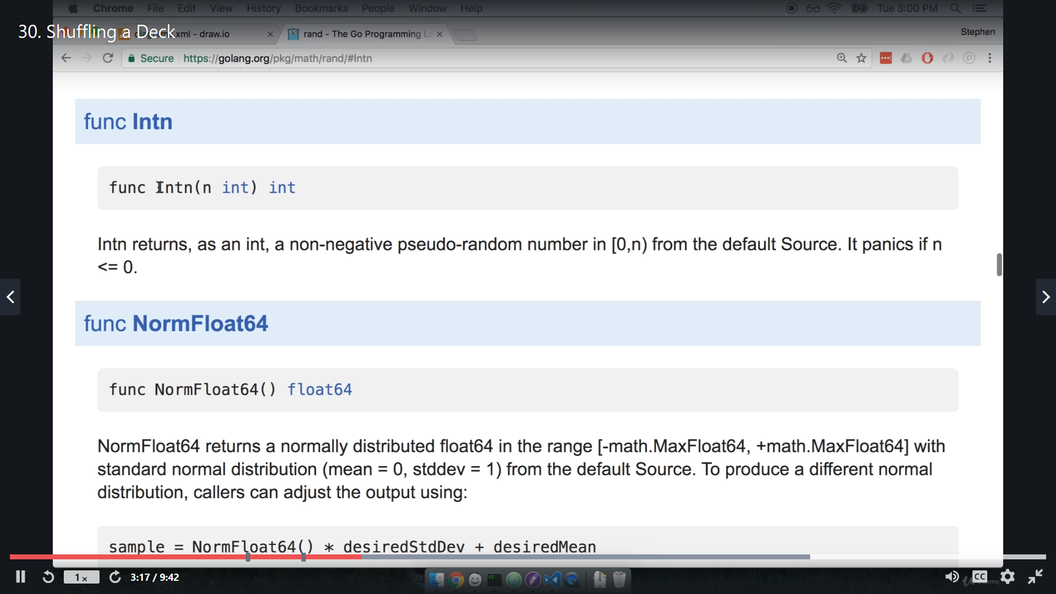

we can use this by **rand.Intn()**

import "math/rand"

func (d deck) shuffle() deck {

    for i := range d {

        newPos := rand.Intn(len(d) - 1)

        d[i], d[newPos] = d[newPos], d[i]

    }

    return d

}

This is one incrediable one line swapper " **d[i], d[newPos] = d[newPos], d[i]**"

but it have one problem for first time it work fine for another time it give same set od random cards.

**Video no -31, name - Random number generation**

**video no -32, name - testing with go**

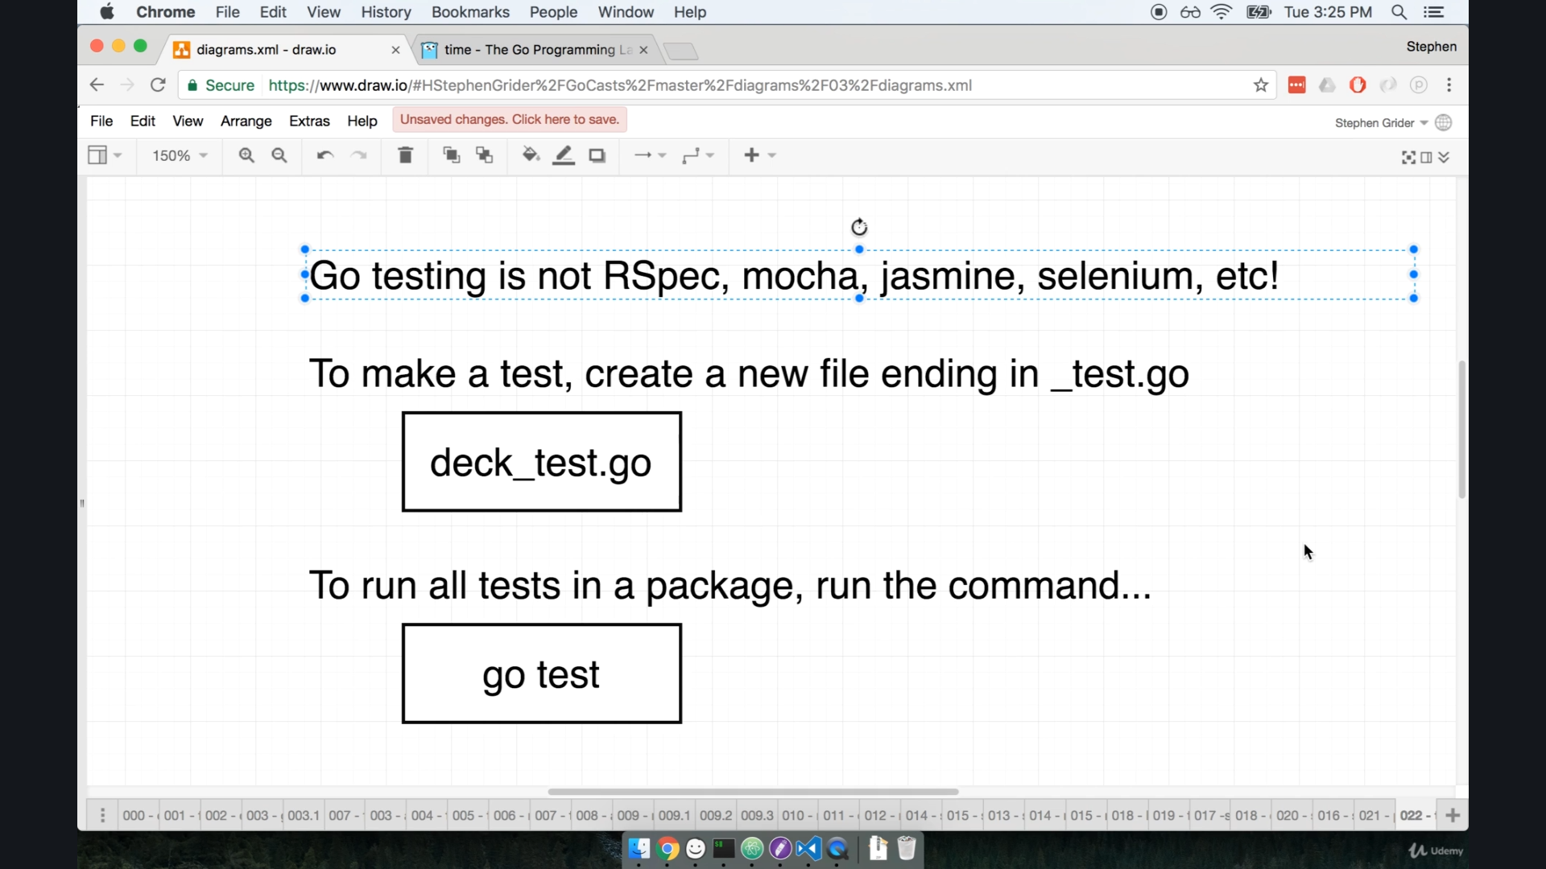

try > go test ==> you will get no test file exist.

lets create a file deck_test.go   
there were two cmd operation like

1. run package test => this will test all the files inside package,
2. run file test => this will test which are mention in that file only.

now when we are writing a _test.go file first thing will come in mind that **what we are going to test**.

there might be thousand of criteria to test a file.

so the answer is what is most important things to care about. on that basis we write test.

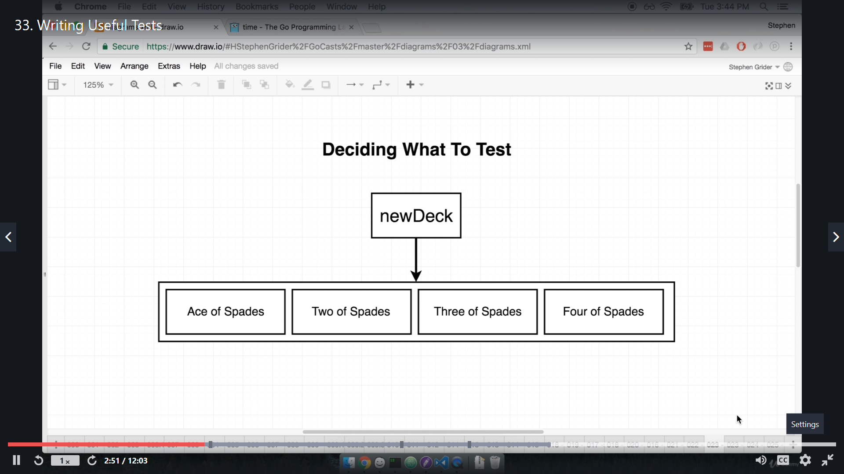

suppose some one mess our code,

so the basic things that matter me most we should put in test, like

take example of newDeck() funtion , the most important things that matters me most is this should contain 12 card or first card should be Ace of Spade.

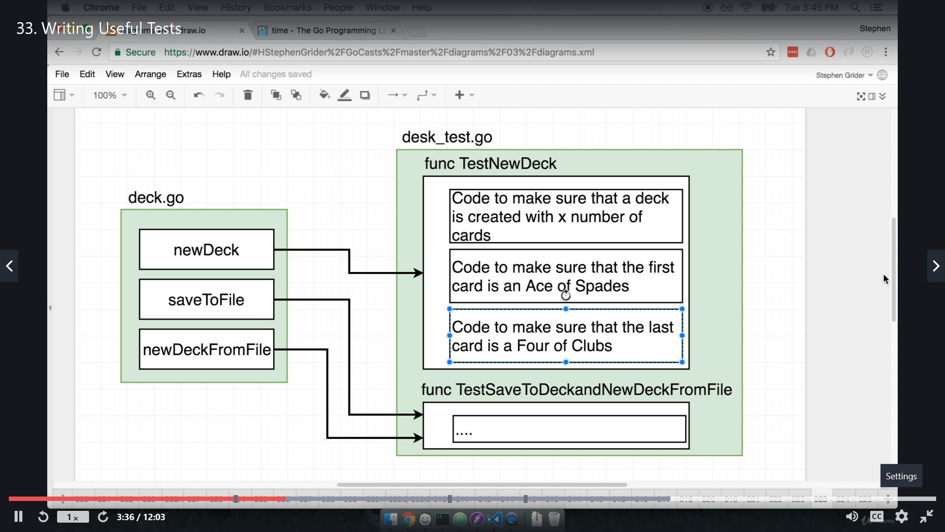

Here we can see that TestNewDeck() function inside desk_test.go file will check about new deck creation.

Also we can create more test function for different main functions.

now lets test this stuff.

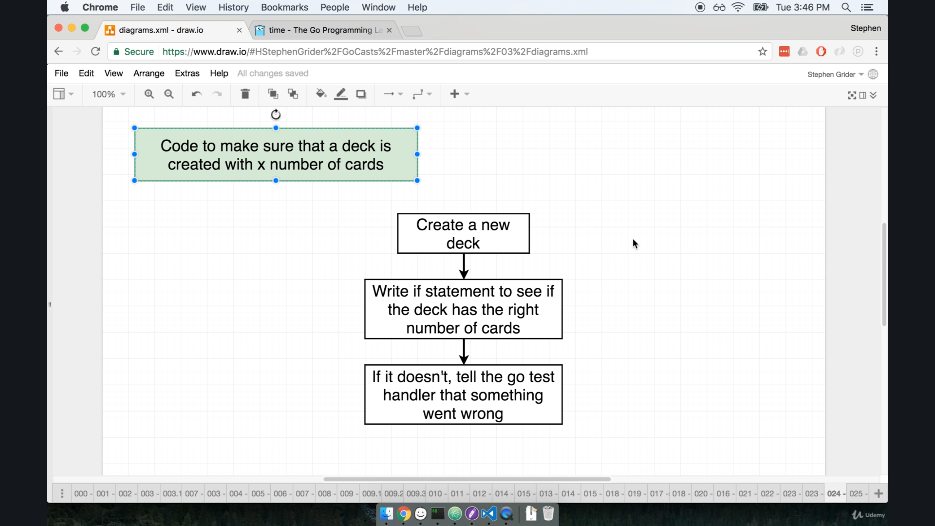

so we will create a function TestNewDeck() (first letter of this function name is also capital),

then we will put some if else statement.

if that fail then we will call **test handler** present in go.

**Note this function will be automatically called by go test runner.**

for that we add an argument like TestNewDeck(**t *testing.T**)

here **t** is our test handler.

if something goes wrong we will tell go that **something went wrong using this test handler t**.

use import statement **testing**

package main

import "testing"

func TestNewDeck(t *testing.T) {

    cards := newDeck()

    if len(cards) != 12 {

        t.Errorf("Test fail in appropriate no of card")

    }

}

PS C:\ARPIT\golang_udemy\go_lang\codes\CARDS> go test

PASS

ok _/C_/ARPIT/golang_udemy/go_lang/codes/CARDS 1.451s

t.Errorf("Test fail in appropriate no of card, but got %v", len(cards))

this is foramtted string use "**%v**"

**Video no - 35, name- Testing File IO:-**

So there is an issue regrading testing while IO operation. like for testing you create a file and at the end of test this file should be deleted, but suppose test fail in between , so due to which file remain in local disk.

so how to remove this file in case of Test fail. is an issue, lets take a look on that.

this diagram shows the issue

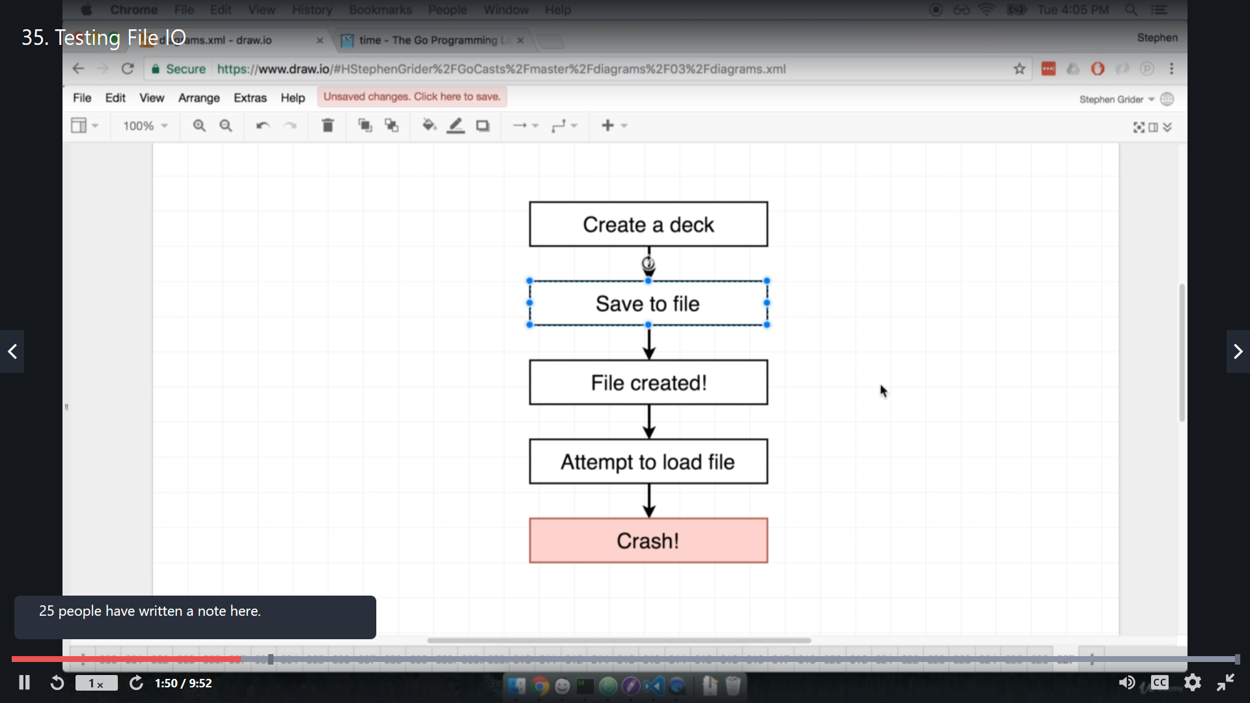

And to resolve that issue we need to do that

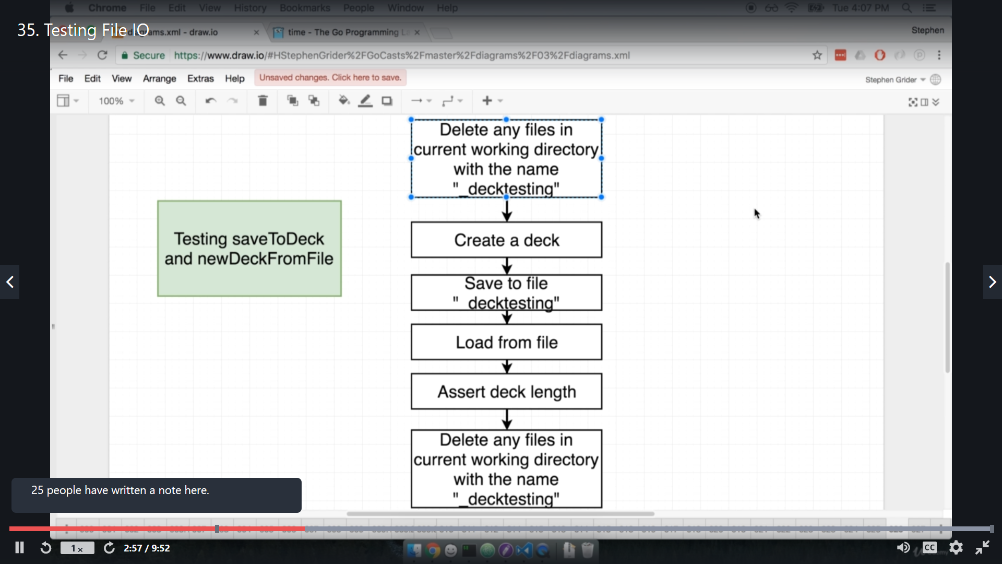

Now the thing is that how to delete a file at all:-

There is an package name - **os** and inside that package we have **Remove function** this is used to remove file.

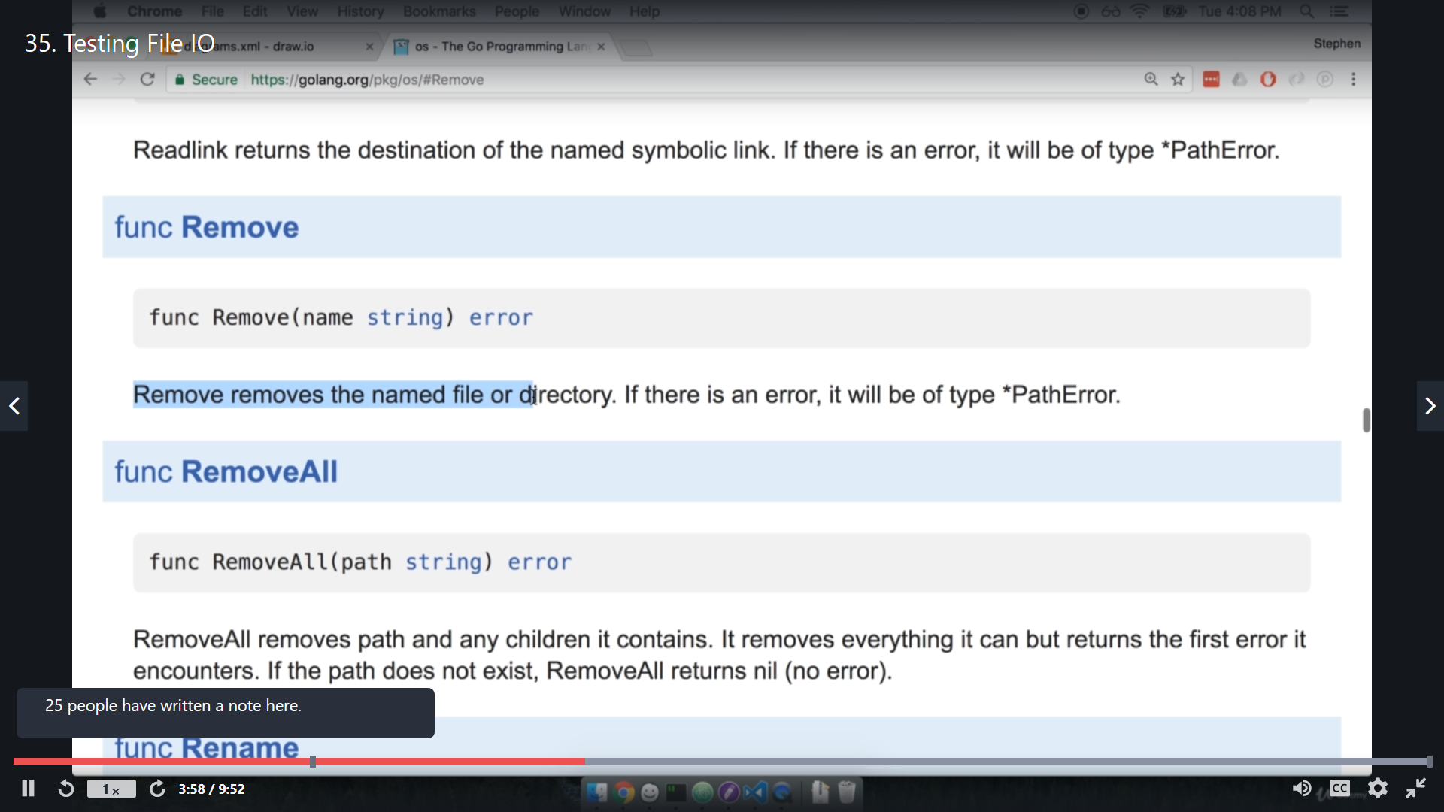

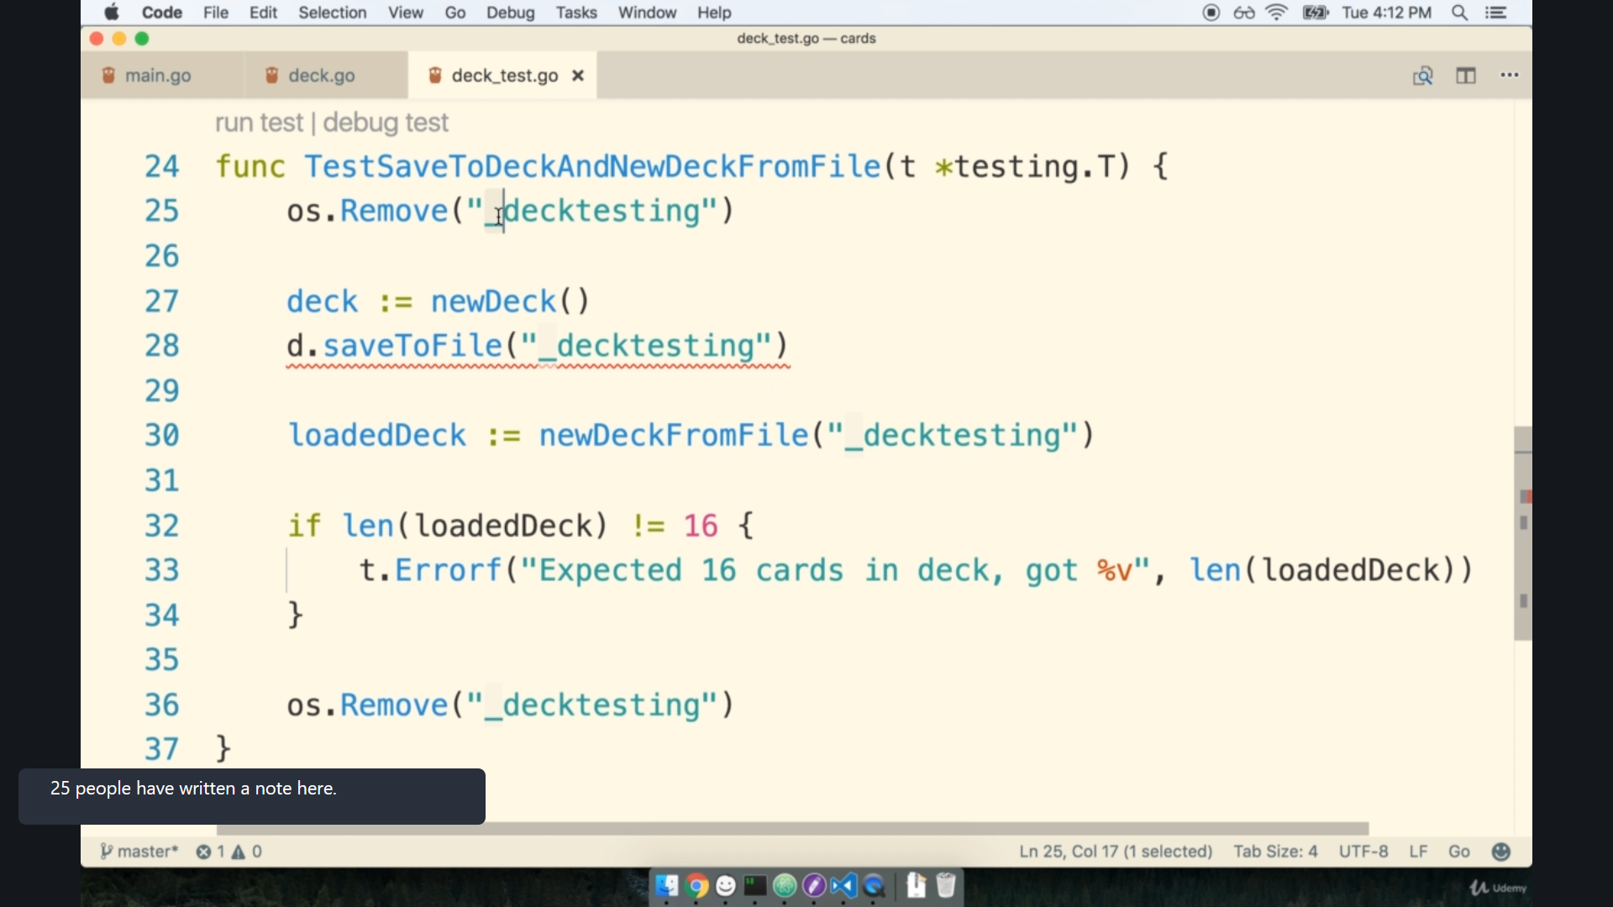

this testing function have "os.remove()" at last, this will ensure that even when test is fail, all clean has been done.